1.Basic Router Configuration
Router Basics and Directly Connected Routing
Objective
To configure a Cisco router and enable communication between two different LANs.
Topology
- 1 Cisco 1941 Router
- 2 Cisco 2960 Switches
- 4 PCs
IP Addressing
LAN1
- Router G0/0 : 192.168.1.1/24
- PC0 : 192.168.1.2/24
- PC1 : 192.168.1.3/24
LAN2
- Router G0/1 : 192.168.2.1/24
- PC2 : 192.168.2.2/24
- PC3 : 192.168.2.5/24
Router Configuration:
->Open the router command line interface
->router> it is normal user command line
1. enable – The router gives the administrative permission
The output: Router#
2.config t / configuration terminal – It set the configuration of the router settings
3.interface gigabitethernet0/0 – we will select the g0/0 for configuration
4.ip address 192.168.1.1 255.255.255.0 – to assign the ip address and also subset for
G0/0
5.no shutdown – default router is shutdown so we say no shutdown
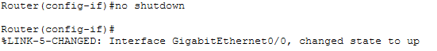
6. exit
7.(LAN -2)select another gigabitethernet1/0 and configure
8.To assign the ip address and subset address
9.no shutdown
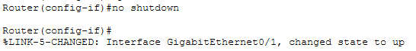
10. end – end of the configuration
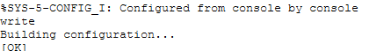
11.show ip interface brief – configured ip are showed.
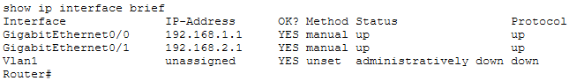

Result Successfully configured a Cisco router to enable communication between two LANs using directly connected routing.
Output:
